Name: __________________ Date: ___________ Block: ___________
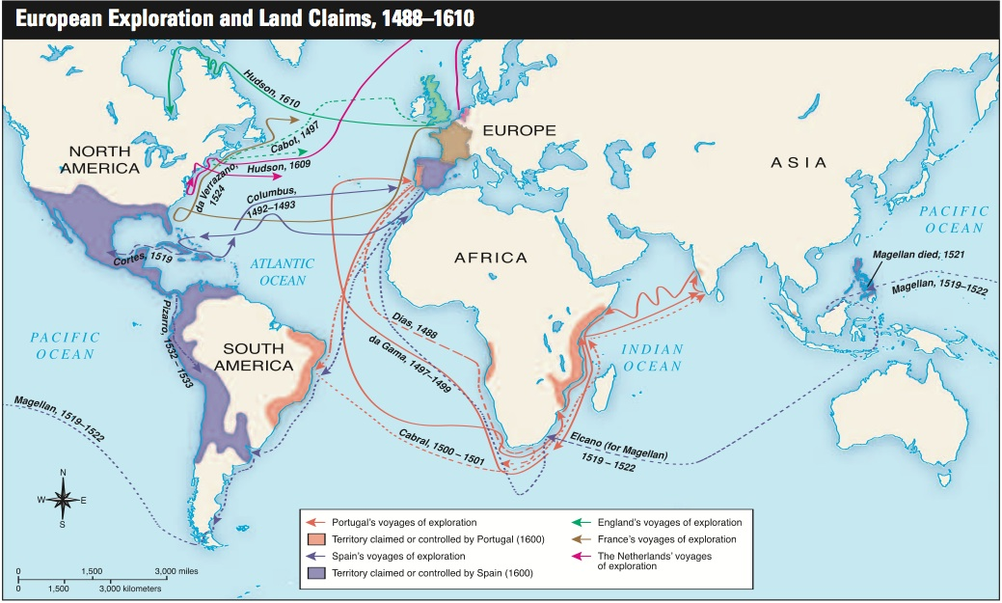
Answer the questions using complete sentences.
You have to study the map above to answer the questions.
1. Which explorer was the first to establish a sea route to Asia?
2. For which European country did he sail?
3. Which explorer was the first to sail to the east coast of South America?
4. For which European country did he sail?

5. By 1600, on which continents did Portugal claim or control territory or cities?
6. Which explorer was the first to sail to what are today the Caribbean Islands, between North and South America?
7. For which European country did he sail?
8. Which explorer was the first to lead a voyage that eventually went around the world?
9. For which European country did he sail?
10. Which country had explorers who led expeditions into the lands of the Aztecs and Incas in North and South America?
11. Who were these explorers?
12. By 1600, on which continents did Spain claim territory?
13. Which European countries during this period sent explorers to North America’s east coast?
14. Name three of these explorers.
15. What year did Magellan die?

