Name _____________________________________ Date ____________________ Block ___________

Unit 3 – 9 Week test review

Directions. Read each of the following questions carefully. Choose the best possible answer.

1. Feudal states arose in both Europe and China directly as a result of
a. the decline of the Roman and Byzantine Empires
b. the fragmentation of central government units
c. poor living and unsanitary conditions in larger towns and cities
d. economic changes brought about by new technologies

2. The split between Sunni and Shi’a Muslims occurred as a result of
a. divergent interpretations of religious texts
b. conflict over the translation of liturgy into native languages
c. disagreement over leadership succession issues
d. a rift between more fundamentalist and more liberal branches of Islam

3. Which of the following is NOT an accurate statement about Confucianism?
a. The ethical system is primarily concerned with relationships.
b. Specific duties are tied to one’s status in society.
c. It prescribes the correct organization of the state to achieve the maximum benefits for the most members of society.
d. Only those who are devout and lead moral lives will be saved.

4. The foundation of ancient Indian civilization is best described by all of the following EXCEPT
a. reincarnation b. the Dao
c. caste d. karma

5. The biggest difference between Melaka and the other states influenced by India was that Melaka
a. played a role in sea trade, while the other states relied on land trade.
b. became predominantly Islamic.
c. started out as mainly Islamic but later converted to Buddhism.
d. built a large, centralized land empire.
e. was predominantly Hindu.

6. “What is recorded in the Buddhist scriptures is analogous to the teachings contained in the scripture of Laozi [the founder of Daoism] in China, and it is actually believed that Laozi, after having gone to India, instructed the barbarians and became the Buddha.”
Yu Huan, Chinese historian, circa 250 C.E.

In the fictionalized account of the origins of Buddhism outlined in the passage above, Yu Huan’s purpose was most likely to

(A) make it easier for his Buddhist readers to convert to Daoism
(B) hint at the existence of an alternate set of Buddhist scriptures that were different from the officially accepted ones
(C) demonstrate the extent of missionary and trade links between China and India
(D) assert the superiority of Chinese culture over non-Chinese cultures

7. Which of the following is a major difference between the social structures of China and
India between 600 B.C.E. and 600 C.E.?

(A) Confucianism emphasized spiritual advancement for people who faithfully performed their social duties.
(B) Merchants had the highest social status in India.
(C) Slaves did most of the agricultural work on large Indian estates.
(D) Confucian social hierarchy privileged government officials.
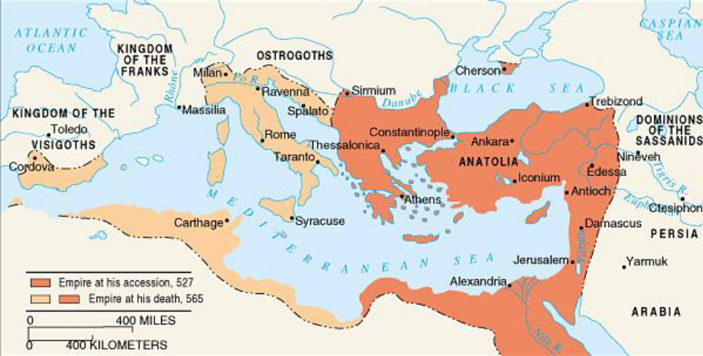
8. This map shows the boundaries of
(A) Charlemagne’s kingdom
(B) Il-Khan
(C) Jagadai
(D) the Byzantine Empire

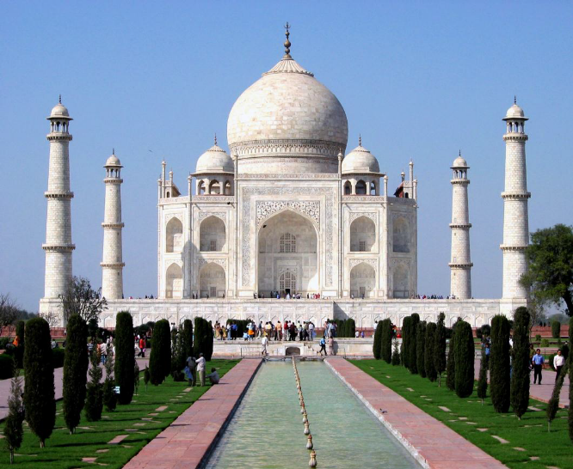
9. This photograph reflects the architectural style preferred in
a. the Ottoman Empire
b. Orthodox Russia
c. the Safavid Empire
d. Mughal India

10. Which of the following Indian concepts did NOT become popular in the southeast Asian states influenced by India?
a. Hinduism
b. the caste system
c. literary classics such as the Ramayana and Mahabharata
d. conducting official business in Sanskrit
e. the creation of a Confucian class of scholarly bureaucrats

The Xiongnu had defeated the king of the Yuezhi people and had made his skull into a drinking vessel. As a result the Yuezhi . . . bore a constant grudge against the Xiongnu, though as yet they had been unable to find anyone to join them in an attack on their enemy. . . . When the emperor [Wudi] heard this, he decided to try to send an envoy to establish relations with the Yuezhi.
- SIMA QIAN, Records of the Grand Historian

11. According to historian Sima Qian and what you know about the Han, which of the following was NOT a form of diplomacy employed by the Han toward the Xiongnu?
a. paying the Xiongnu tribute
b. resettling the Xiongnu border area with Chinese soldiers
c. creating alliances with the enemies of the Xiongnu
d. creating confederacies and recruiting Xiongnu into the ever expanding bureaucracy

12. The presence of the changing monsoon winds ensured that
a. irrigation never developed in India, because it was never necessary.
b. India enjoyed complete isolation.
c. shipping was impossible in the Indian Ocean basin.
d. irrigation was necessary in arid southern India.
e. the Indian religious hierarchy would be dominated by one great storm god.

13. Hindu temples
a. played an important role in the agricultural and financial development of southern India.
b. were never able to compete with the strong Buddhist temples of northern India.
c. held southern India back economically because of the Hindu law against lending money.
d. disappeared in southern India because of the prominence of Islam.
e. remained centers of women’s rights.

14. The bhakti movement
a. never caught on in India as it had in China.
b. appealed to Indians who were stifled by the strictly monotheistic views of Hinduism.
c. tried to find god through a strictly rationalistic pursuit of the divine.
d. sought to erase the distinction between Hinduism and Islam.
e. sought to erase the distinction between Hinduism and Buddhism.

15. Which of the following was NOT a factor weakening kingdoms in Europe after the death of Charlemagne?

(A) Viking invasions (B) The fighting among Charlemagne’s grandsons
(C) Disruption of the Silk Road trade (D) Invasions from Scandinavian people.

16. Which of the following modern day countries did the Vikings NOT come from?

(A) Denmark (B) Norway
(C) Netherlands (D) Sweden

17. Which statement best describes why feudalism developed?

(A) People turned to landed aristocrats for protection with the break-down of imperial order.
(B) Constant attacks by the Huns forced men to develop new methods of warfare.
(C) Feudalism developed out of the growth of a new powerful middle class.
(D) The Byzantine emperor’s decision to parcel western Europe among his lords.
18. Under feudalism, a warrior who served a lord was known as a
(A) vassal (B) earl
(C) count (D) aristocrat

19. A fief was a
a. grant of land b. outlaw
c. church office d. code of laws

20. A code of ethics knights were held to was called
a. scholasticism b. chivalry
c. feudalism d. vassalage

21. The chief virtue in Feudal society was
a. charity toward one’s neighbor b. skill at arms
c. loyalty to one’s lord d. skill at farming

22. The relationship between a lord and his vassal was an unwritten set of mutual obligations known as
a. the feudal contract b. the code of chivalry
c. the Magna Carta d. the Code of Roland

23. From the fall of Rome to the twelfth century, ________ was the political and economic powerhouse of the Mediterranean region.
a. France b. Byzantine Empire
c. Frankish Kingdom d. Italy

24. “We’ve heard the elders say, ‘When two men become anda their lives become one. One will never desert the other and will always defend him.’ This is the way we’ll act from now on. We’ll renew our old pledge and love each other forever.”

.....They held a feast on the spot and there was great celebration.

The excerpt above from The Secret History of the Mongols illustrates the Mongols’ central value of

a. conquest b. loyalty ties
c. hierarchica d. feasting and celebration
25. The Tang plan to avoid the concentration of land in the hands of the wealthy was called the
a. Hangzhou system.
b. Tang Taizong system.
c. kowtow system.
d. equal-field system.
e. new economic plan.

26. During the Tang dynasty, the imperial civil service examinations
a. declined dramatically in importance.
b. were expanded, allowing posts to be filled with officials of genuine intellectual ability.
c. were halted and not restarted until the Ming dynasty.
d. were restricted to the wealthier families.
e. were monopolized by the foreign Manchus and used for their advantage.
27. During the Tang dynasty,
a. powerful neighbors kept the Chinese from expanding.
b. most of far western China fell to barbarian tribes.
c. Japan was brought under complete Chinese control.
d. Chinese armies pushed into Korea, Manchuria, Tibet, and northern Vietnam.
e. Japanese forces captured northern China.

28. The kowtow
a. was the “south-pointing needle.”
b. was the most popular school of Buddhism in China.
c. was a ritual prostration before the Chinese emperor.
d. was the word that neo-Confucian scholars used when discussing physical matter.
e. was a fast Chinese ship that played a key role in expanding trade.

29. The Song dynasty was substantially weakened by Song Taizu’s decision to
a. invade India.
b. allow scholar-bureaucrats to lead the army.
c. dismantle the Chinese bureaucracy.
d. give his generals almost unlimited authority.
e. turn control of the state over to his brilliant Korean bureaucrats.

30. The most important new crop introduced into China during the Tang and Song periods was
a. cotton. b. fast-ripening rice.
c. indigo. d. oranges. e. barley.

31. Foot binding is probably the best example of the
a. technological brilliance of the Song dynasty.
b. influence of Buddhist customs as the religion became popular in China.
c. increasingly patriarchal nature of Chinese society.
d. influence of Japanese traditions on the Chinese.
e. increasing freedom of Chinese women during the Song dynasty.

32. The most influential Chinese naval technological innovation was the
a. use of rudders. b. magnetic compass.
c. triangular sail. d. shipboard cannon. e. invention of steel hulls.

33. The Islamic pilgrimage to Mecca is known as the
a. hajj. b. hijra.
c. qadis. d. sharia. e. jizya.

34. The presence of the changing monsoon winds ensured that
a. irrigation never developed in India, because it was never necessary.
b. India enjoyed complete isolation.
c. shipping was impossible in the Indian Ocean basin.
d. irrigation was necessary in arid southern India.
e. the Indian religious hierarchy would be dominated by one great storm god.

35. The Quran
a. is the holy book of Islam.
b. were the priests who watched over the Ka’ba.
c. was Muhammad’s journey to Yathrib.
d. is the law code of Islam.
e. were Islamic scholarly bureaucrats.

36. The Islamic holy law is known as the
a. umma. b. sharia.
c. ulama. d. qadis. e. hijra.

37. After the death of Muhammad, political leadership fell to a caliph by the name of
a. Abu Bakr. b. Ali.
c. Abu al-Abbas. d. Harun al-Rashid. e. Khadija.

38. The Shia believe that
a. the Umayyad dynasty were the only legitimate rulers.
b. the caliphate should follow the line of Ali.
c. that Allah was the main, but not necessarily the only, god.
d. leadership in the Islamic world could fall to any true believer.
e. a different and more pure version of the Quran exists.

39. The main split inside Islam was between Sunni and
a. Ulama. b. Qadis.
c. Shia. d. Umayyads. e. Sufis.

40. The Umayyad insisted that conquered people pay a special head tax if they did not convert to Islam. This head tax was called the
a. sakk. b. ulama.
c. hajj. d. shia. e. jizya.

41. What new industry, transmitted to the Islamic world from China, was introduced during the Abbasid period?
a. steel production b. paper manufacture
c. bronze production d. textile production e. iron production

42. From which region did the Muslims adopt their numerals?
a. Persia b. Greece
c. India d. Arabia e. Egypt

43. The mixture of secular and religious authority that marked Constantine’s reign as well as that of the Byzantine emperors is known as
a. Byzantine. b. caesaropapism.
c. Corpus iuris civilis. d. secularism. e. divine right rule.

44. The wife of Justinian, who proved to be an invaluable adviser, was
a. Belisarius. b. Livia.
c. Hagia Sophia. d. Theodora. e. Olympia.

45. Justinian’s most important and long-lasting political achievement was
a. his reconquest of the western half of the Roman empire.
b. his democratic reforms.
c. his religious compromise between the Roman Catholic and the Greek Orthodox churches.
d. his codification of Roman law.
e. his establishment of a lasting peace with the Islamic world.

46. After the collapse of western Roman authority,
a. Germanic tribes established regional kingdoms.
b. a greater pan-Germanic empire was established.
c. the Visigoths created imperial unity.
d. the Byzantine empire expanded into the west to re-create a lasting imperial state.
e. Europe was overrun and united by Islamic forces.

47. Roman imperial power ended in 476 C.E. with the invasion of
a. the Germanic general Odovacer.
b. the Byzantine emperor Justinian.
c. the Frankish chieftain Clovis.
d. the Emperor Otto I.
e. the Islamic ruler Harun al-Rashid.

48. Which Germanic tribe played the most important role in establishing the foundations of European development?
a. Visigoths b. Angles
c. Franks d. Ostrogoths e. Vandals

49. In 1054 the pope in Rome and the patriarch in Constantinople
a. met at the Council of Milan to settle old differences.
b. mutually excommunicated each other.
c. agreed on a joint plan to bring Christianity to Russia.
d. jointly called for a new crusade.
e. agreed on a highly controversial plan to eliminate the Protestants.

50. A direct challenge to the Byzantine emperor arose in the year 800 when the pope gave an imperial crown to the Frankish king,
a. Otto of Saxony. b. Charlemagne.
c. Basil II. d. Cyril. e. Hugh Capet.

Answer Key

1. b 2. C 3. d
4. b 5. b 6. D
7. d 8. D 9. D
10. b 11. d
12. d 13. a 14. d

15. C 16. C. 17. A 18. A. 19. A
20. B 21 C. 22 a. 23 b 24 b

25. d 26. B 27. D 28. c

29. b

30. b
31. c
32. b

33. a
34. d

35. a
36. b
37. a
38. b
39. c
40. e
41. b
42. c
43. b 44. D 45. D 46. a 47. A 48. C
49. b 50. b

