Name: __________________________ Date: ______________

Mr. Wyka’s Amazing 9 week Exam Review – Part 1 of 12,353.

Almost Every Graph We’ve Gone Over Thus Far…
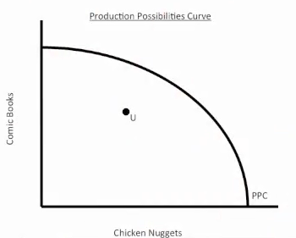
1. Point U represents unemployed resources and is _______________________. (Don’t worry, the questions get tricksier.)

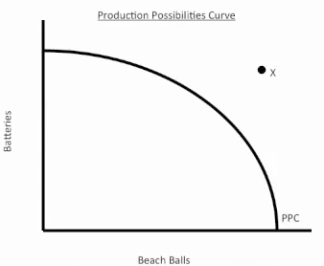

2. In the present, point X is
____________________________________.

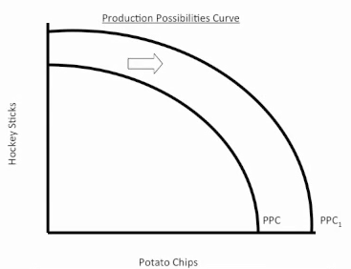
3. A rightward shift of the Production Possibilities Curves indicates ______________________________________.
___________________________________________________________________________________________
4. What might cause an outward shift of the PPC? ______________________________________________________________________________________________
_______________________________________________

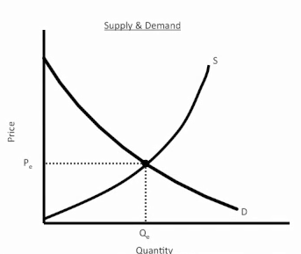
5. The point where Supply intersects Demand indicates a market in __________________________.

6. What is the Law of Demand? __________________
_____________________________________________
7. What is the Law of Supply? __________________
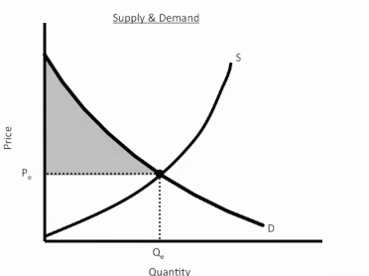
_____________________________________________
8. The shaded region indicates __________________ ____________________________________________.
9. In your own words, define Consumer Surplus (remember the Pearl Exchange): _________________
_____________________________________________
____________________________________________.
10. In your own words, define Producer Surplus:
_____________________________________________
________________________________________________.
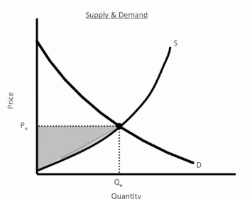
11. Equilibrium in any market exists where the demand curve intersects supply. The shaded region on the graph to the right indicates: ____________________________________________________________________________________

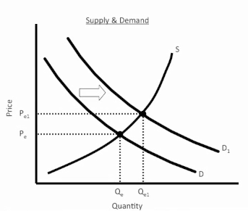
12. When Demand shifts right:
Market price _______
Quantity _______

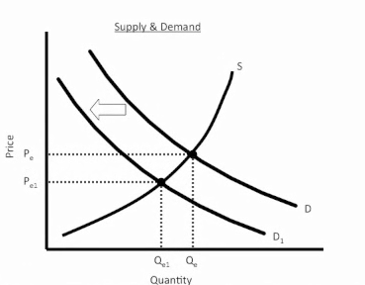
13. When Demand shifts left:
Market price _______
Quantity _______

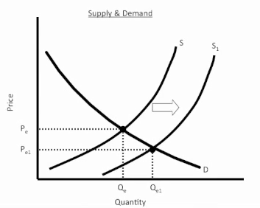

14. When Supply shifts right:
Market price _______
Quantity _______

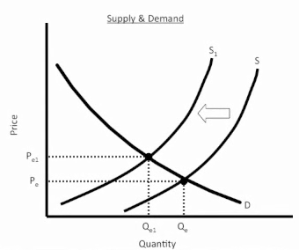
15. When Supply shifts left:
Market price _______
Quantity _______

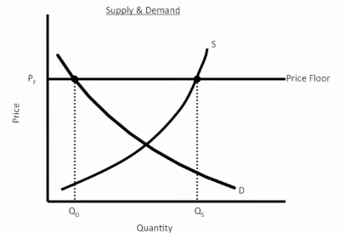

16. An effective price floor causes a ______________ of the good.
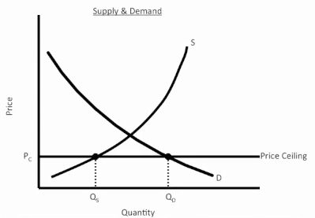

17. An effective price ceiling causes a ______________ of the good.

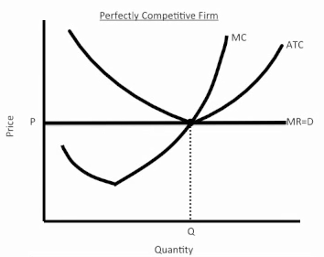

18. Is this PC Firm in Long Run or Short Run?
_______________________________
19. Is it breaking even, earning a profit, or taking a loss? __________________________________

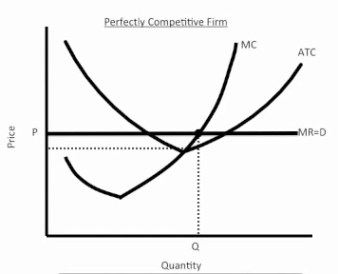

20. Is this PC Firm in Long Run or Short Run?
_______________________________ Is it breaking even, earning a profit, or taking a loss? ____________ __________________________________

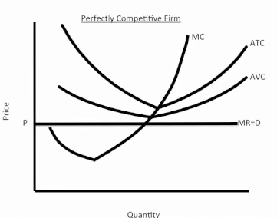

21. Should this Short Run firm (right) shut down production or continue producing?
____________________________________

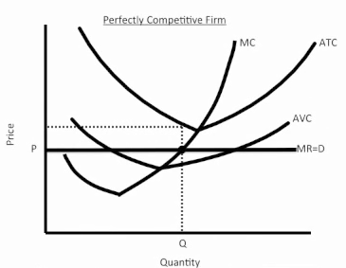

22. Is this PC Firm (left) in Long Run or Short Run?
_______________________________ Is it breaking even, earning a profit, or taking a loss? ____________ __________________________________
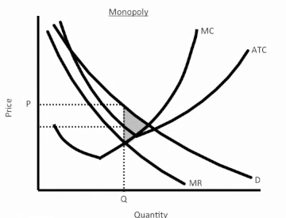

23. Is this Monopoly making a loss, a profit, or breaking even? ___________________________
What does the shaded region indicate? ________
_________________________________________

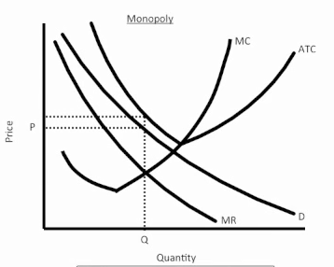
24. Is this Monopoly making a loss, a profit, or breaking even? ___________________________
If a loss or a profit, shade in the region indicating the loss or profit.

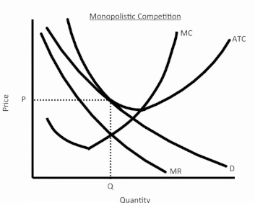

25. Is this Monopolistic Competitor in Long Run Equilibrium, Short Run Profit, or Short Run Loss? ________________________________________

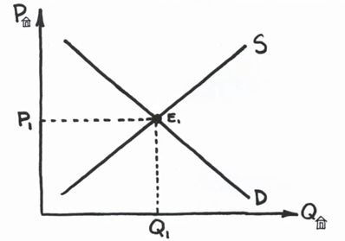

26. The graph to the left indicates the housing market at equilibrium. What would happen to the graph (the market) if the interest rate banks charged homebuyers for home mortgages increased dramatically? You can either explain your answer fully, or draw one or more graphs below indicating what would happen to this market. ________________________________________
_____________________________________________________________________________________
_____________________________________________________________________________________

Answer key:

1. inefficient
2. unattainable
3. economic growth
4. 3 Shifters of the PPC - 1. Change in resource quantity or quality 2. Change in Technology 3. Change in Trade
5. equilibrium
6. There is an INVERSE relationship between price and quantity demanded.
As Price Falls… Quantity Demanded Rises As Price Rises…Quantity Demanded Falls
7. There is a DIRECT (or positive) relationship between price and quantity supplied.
  - As price increases, the quantity producers make increases
  - As price falls, the quantity producers make falls.
8. consumer’s surplus
9. Something to the effect that it is the differences between what a consumer is willing to pay and what he has to pay to get the product
10. Something to the effect that it is the difference between what a producer is willing to sell the product for and what the producer actually sells the product for.
11. producer’s surplus
12. rises, rises (both increase) 13. Both decrease
14. price decreases, quantity increases 15. P Increases, Q decreases
16. surplus 17. Shortage
18. Long Run 19. breaking even or earning normal profits only
20. short run, profit 21. Shut down. Price is less than ATC and minimum AVC at MR=MC.
22. short run, loss 23. Profit as Price exceeds ATC when MR=MC, dead weight loss
24. loss 25. Long run equilibrium
26. The Demand Curve would shift left, indicating a drop in Demand for homes. Price would adjust downward until the new P / Q intersection is found.

