AP Microeconomics Review – With Answers
1. Firm in Perfect Competition (Long-Run Equilibrium)
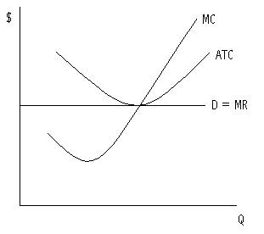
2. Monopoly Industry with comparison of price & output of a Perfectly Competitive Industry
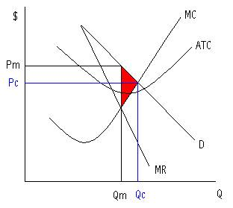
3. Natural Monopoly with Fair-Return and Socially-Optimum Regulation
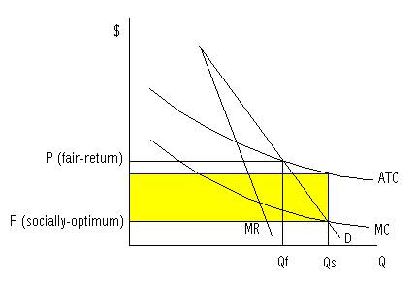
4. Negative Externality showing that too much is being produced at too low of a price
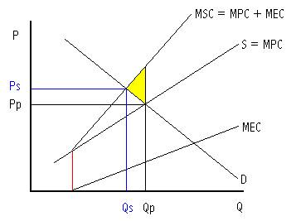
5. Positive externality showing that too little is being produced at too low of a price
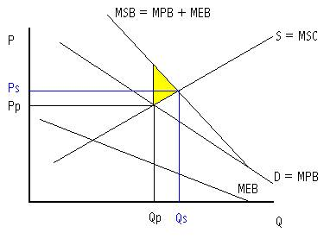
6. Monopsony Labor Market with comparison of workers hired and wage rate in a p.c. labor mkt.
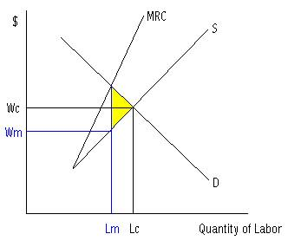
7. Production Possibilities Curve illustrating the concept of opportunity cost
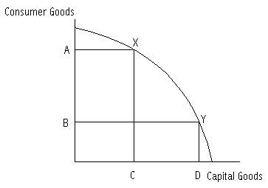
8. MP_{L} and AP_{L} (As long as the additional worker (MP_{L}) is > than the average, AP_{L} is rising)
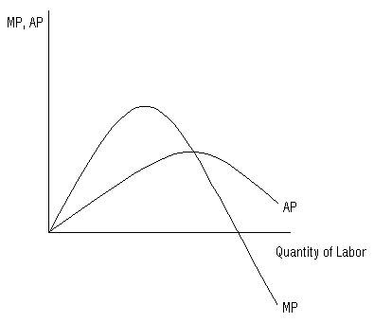
9. Perfectly Competitive Labor Market with Total Labor Costs in red and Non-labor Costs in yellow
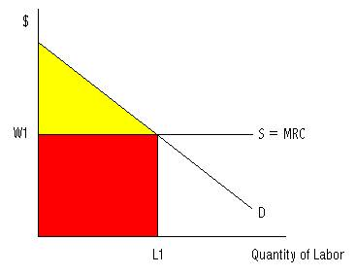
10. TP (Total Product) with MP and AP curves below to show the stages of production, return rates,and relationship between MP and TP (As long as MP > 0, TP is increasing)
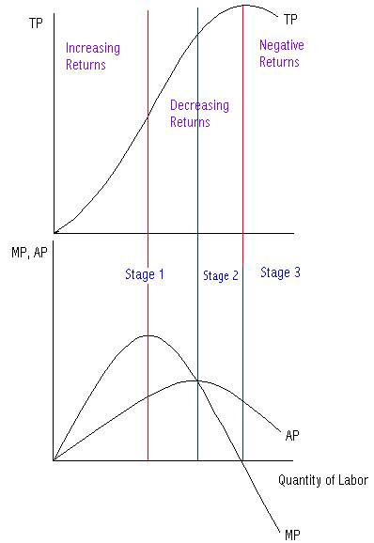

11. Illustration of an effective Price Floor creating a Surplus since Qs > Qd
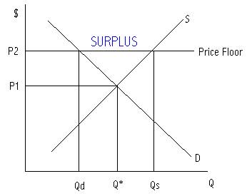
12. Illustration of an effective Price Ceiling creating a Shortage since Qd > Qs
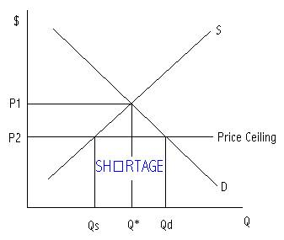
13. Market in equilibrium with Consumer surplus shaded in yellow
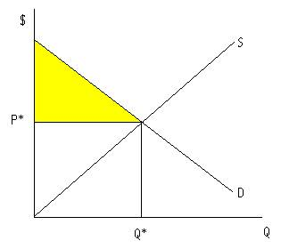
14. Illustration of Perfectly Inelastic supply or demand
15. Illustration of Elastic Demand
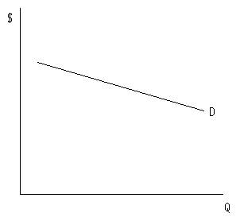
16. Illustration of Inelastic Demand
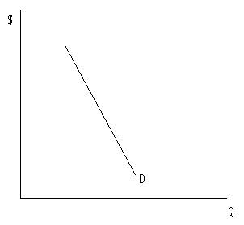

17. Illustration of Perfectly Elastic supply or demand
18. Illustration of a Long-Run Average Total Cost Curve (∑ ATC curves for various plant sizes)
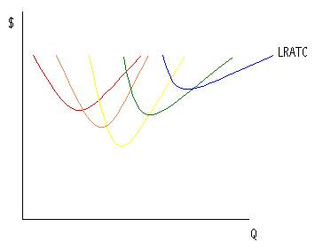
19. TFC + TVC = TC
20. TFC / Q = AFC
21. TVC / Q = AVC
22. AFC + AVC = ATC
23. TC / Q = ATC
24. ∆ TC / ∆ Q = MC
25. TR / Q = AR or P
26. ∑ MP = TP (Output)
27. P x Q = TR
28. ∆ TR / ∆ Q = MR
29. ∆ TP / ∆ L = MP_{l}
30. TP / L = AP_{L}
31. AR < AVC : Shutdown
32. % ∆ QD / % ∆ P = E_{d} (Elasticity of Demand) Coefficient
33. P = ATC : Fair-Return Regulation (0 Economic Profit or Normal Profit)
34. P = MC : Socially-Optimum Price Regulation (Allocative Efficiency)
35. P > MC : Underallocation of Resources
36. P < MC : Overallocation of Resources
37. MU_{A} / P_{A} = MU_{B} / P_{B} : Equimarginal Rule (Utility Maximization Rule)
38. MP_{A} / P_{A} = MP_{B} / P_{B} : Least-Cost Rule
39. MR = MC : Optimal Output Rule (Profit Maximization)
40. MRP = MRC : Hiring Rule
41. MP x P = Marginal Revenue Product (MRP)
42. MRP_{A} / P_{A} = MRP_{B} / P_{B} = 1 : Profit-Maximization Rule
43. TR – TC = Profit
44. P > ATC : Economic Profit
45. P < ATC : Economic Loss
46. MR < 0 : Demand is inelastic (TR is declining)
47. MR > 0 : Demand is elastic (TR is rising)
48. MR = 0 : Demand is unit elastic (TR is at a maximum)
49. ∆ TR / ∆ Input = Marginal Revenue Product (MRP)
50. ∆ TC / ∆ Input = Marginal Resource Cost (MRC)
51. P = Min ATC : Productive Efficiency
52. e_{d} < 1 : Demand is inelastic
53. e_{d} > 1 : Demand is elastic
54. e_{d} = 1 : Demand is unit elastic
55. ∆ Price = Movement Along the Curve
56. ∆ Non-Price Determinant = Shift of the Curve
57. P Increases, TR increases : Demand is inelastic
58. P increases, TR decreases : Demand is elastic
59. P decreases, TR decreases : Demand is inelastic
60. P decreases, TR increases : Demand is elastic
ADDITIONAL THINGS YOU SHOULD KNOW!
1. Ways for the government to correct positive externalities.
Ø Positive externalities provide additional benefits to society. There is currently an underallocation of resources and society wants more of the good or service. Therefore, the government could correct this by providing a corrective subsidy (s* = MEB) or by simply using the command approach (and establishing standards).
2. Ways for the government to correct negative externalities.
Ø Negative externalities inflict additional costs on society. There is currently an overallocation of resources and society wants less of the good or service. Therefore, the government could correct this by passing a corrective tax on the behavior (or product) or by simply using the command approach (and establishing standards).
3. Justification for government regulation of a monopoly.
Ø A monopoly charges a higher price than the competitive market price and produces too little of a good or service.

4. Definition of inferior goods.
Ø As income ↑(↓), demand ↓(↑).
5. Definition of normal goods.
Ø As income ↑(↓), demand ↑(↓).
6. Assumptions of the PPC (Production Possibilities Curve).
Ø 2 goods, full-employment, full-production, and resources & technology are fixed.
7. What would cause the PPC to shift inward and outward.
Ø Changes in the resource supply and capital. Anything that improves the allocation of resources or the productivity of resources. Changes in unemployment (or underemployment) would NOT result in a shift of the PPC.
8. Adam Smith’s view on the nature of the economy and economic growth.
Ø The economy is driven by a self-regulating mechanism. The economy will grow at a steady rate and there will be economic growth in the long run.
9. Fair-Return vs. Socially-Optimum Return (Which one might require a payment of a subsidy to the firm?).
Ø Fair-Return: The government sets price equal to average total cost (P = ATC). Remember, the price is set equal to ATC, it doesn’t mean it has to be set equal to minimum ATC.
Ø Socially-Optimum Return: The government sets price equal to marginal cost (P = MC). Typically this will require a subsidy to the firm because P < ATC.
10. Characteristics of elastic and inelastic goods (elastic, inelastic, perfectly elastic, perfectly inelastic).
Ø Elastic goods: Many substitutes, luxury goods, large % of income.
Ø Inelastic goods: Few substitutes, necessities, small % of income.
Ø Perfectly elastic goods: No product differentiation.
Ø Perfectly inelastic goods: One-of-a-kind product!

11. Economic Roles of the government.
Ø The economic roles of the government are to provide a legal structure, maintain competition, redistribute income, reallocate resources, and promote stability.
12. What are variable costs?
Ø Costs that change as production changes. These costs can be avoided in the short run. Some examples include wages for labor and payments for electricity.
13. Derived Demand.
Ø The demand for a resource depends on the demand for the product it produces.
14. Determinants of Resource Demand.
Ø Demand for the product it produces (Product price), productivity of the resource (MP), and the price of other resources (substitutes and complements).
15. Determinants of Supply and Demand.
Ø The determinants of supply are: the price of resources, # of sellers, price of related goods in production (substitutes and complements), taxes, subsidies, technology, and expectations.
Ø The determinants of demand are: tastes & preferences, # of buyers, price of related goods in consumption (substitutes and complements), income, and consumer expectations.
16. Definition of Marginal Resource Cost, Marginal Revenue Product, Marginal Revenue, and Marginal cost (in words).
Ø Marginal Resource Cost (MRC) = ∆ Total Resource Cost / ∆ Units of Resource.
Ø MRC is the additional cost from employing an additional unit of resource.
Ø Marginal Revenue Product (MRP) = ∆ Total Revenue / ∆ Units of Resource or MP x P.
Ø MRP is the additional revenue from employing an additional unit of resource.
Ø Marginal Revenue (MR) = ∆ Total Revenue / ∆ Output.
Ø MR is the additional revenue from producing one more unit of output.
Ø Marginal Cost (MC) = ∆ Total Cost / ∆ Output.
Ø MC is the additional cost from producing one more unit of output.
17. How to apply the Least-Cost Rule.
Ø If MP_{c}/P_{c} > MP_{l}/P_{l}, buy more capital and fire workers!
Ø If MP_{c}/P_{c} < MP_{l}/P_{l}, sell some capital and hire more workers!
18. What to do when facing a surplus or shortage in order to clear the market (to reach equilibrium).
Ø When facing a surplus, lower prices.
Ø When facing a shortage, raise prices.
19. Definition of Price Discrimination.
Ø Price discrimination occurs when a producer sells a given product or service at different prices that don’t reflect cost differences.
20. Concepts involving the Production Possibilities Curve.
Ø If society chooses to produce more capital goods now, it means that they’ll have greater ability to produce more in the future.
Ø Unless we are at a point inside the curve, the opportunity cost of having more of something else will be positive.
21. What would cause a firm’s short run cost curves (MC, AVC, and ATC) to shift?
Ø Any change in variable costs (such as wages, resource prices, etc).
22. Definition of Diminishing Marginal Returns and the point at which it occurs.
Ø As you add additional inputs to a fixed input at some point you’ll experience smaller returns on that input.
Ø Diminishing returns occurs when MP (marginal product) is at a maximum or MC (marginal cost) is at a minimum.
23. Definition/Characteristics of Perfect Competition, Monopolistic Competition, Oligopoly, Monopoly, and Monopsony.
Ø Refer to comparison grid!

24. Why is a monopolistically competitive firm allocatively inefficient in the long run?
Ø Since it’s easy to enter and exit the industry, the firm will make 0 economic profits in the long run. But, it will still be producing where P > MC because D > MR.
25. How to apply the Total Revenue Test.
Ø Inelastic: As P↑(↓), TR↑(↓). This is true because the %∆P > %∆QD (making ed < 1).
Ø Elastic: As P↑(↓), TR↓(↑). This is true because the %∆QD > %∆P (making ed > 1).
Ø Unit Elastic: As P↑(↓), TR does NOT change! This is true since the %∆QD = %∆P (ed = 1).
Ø * Remember ed (coefficient of elasticity of demand) = %∆QD / %∆P.
26. What can happen during the short run?
Ø Period of time in which output can be changed by adjusting only the variable inputs. There isn’t enough time to build a new factory and such.
27. Nominal Wages vs. Real Wages.
Ø Real = Nominal – Inflation.
Ø Real wage is the purchasing power of one’s nominal wage.
28. What are the factor payments for land, labor, Capital, and Entrepreneurship?
Ø Rent (land), wages (labor), interest (capital), income (entrepreneurship).
29. Definition of Free-Rider and how it applies to public goods.
Ø Free-riders receive the benefits of goods/services without paying for them. This is why private businesses typically don’t produce these goods. If they did, they would produce less than the socially optimal amount.
30. Characteristics of Natural Monopolies.
Ø Natural monopolies usually have high fixed costs, would be inefficient if they were divided into many smaller businesses, and they are often regulated by the government.

31. What are some barriers to entry?
Ø Barriers to entry include: high start-up costs, economies of scale, and government regulations (licenses, patents, etc).
32. Why do long run average total costs eventually rise as a firm grows larger?
Ø Diseconomies of scale occur when firms become too big. Problems with distant management may be one source of the increasing costs.
33. Explain the relationship between Demand and Marginal Revenue for a Monopoly.
Ø D > MR since the monopolist must lower his or her price in order to sell more units, and that lower price applies to all previous units.
34. Allocative and Productive Efficiency in the various market structures.
Ø Perfectly Competition: P = MC and P = min ATC.
Ø Monopolistic Competition: P > MC and P = ATC.
Ø Monopoly: P > MC and P > ATC.
Ø The only industry that is allocatively and productively efficient is perfect competition.
Ø Remember, allocative efficiency occurs when P = MC and productive efficiency occurs when P = min ATC.
35. Entry and Exit into various market structures in the long run.
Ø Perfect competition and monopolistic competition are the only industries in which there is entry and exit in the long run since there are relatively few barriers to entry.
36. Graphical representations of Perfect Competition, Monopoly, Purely Competitive Labor Market, and Monopsony.
Ø See graphs above!
37. How to properly label economic graphs!
Ø Remember to label our axes and curves. Also, make your graphs look neat!

