Name: ________________________ Date: _______________ Period: ______________
Southwest Asia - Identify as many of the modern countries and bodies of water numbered below as you can from memory first. Then, you may use the class maps or Atlases as sources.
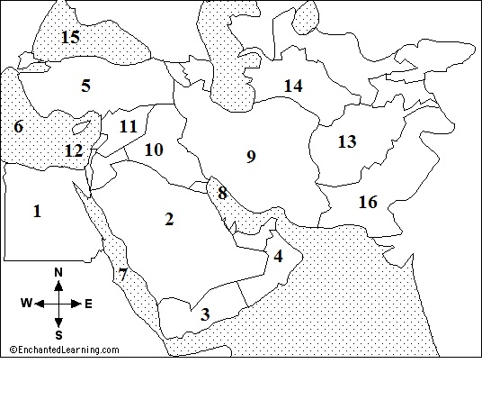
1. _______________________ 2. _______________________ 3. _________________________
4. _______________________ 5. _______________________ 6. _________________________
7. _______________________ 8. _______________________ 9. _______________________
10. _______________________ 11. _______________________ 12. _________________________
13. _______________________ 14. _______________________
15. _________________________ 16. _______________________

