Name: ___________________________ Block:_______ Date:____________________

TEST REVIEW – Chapter 11 – The Age of Exploration - Use your notes from class lectures, your textbook, and guided readings to answer the following questions.

1. A small, fast, maneuverable ship that had a large cargo hold and usually three masts with lateen sails: Caravel . This type of ship was developed by Prince Henry of Portugal.
2. A settlement of people living in a new territory, linked with a parent company or state by trade and government control is called a colony.
3. A leader in the Spanish conquest of America is called a conquistador.
4. Europeans were fascinated with Asia, in part due to the overland journeys of Marco Polo to Asia in the 13th century.
5. “Gold, Glory, and GOD is a phrase that suggests the three key motivations for European expansion.
6. Choose the date closest to the beginning of the Age of Exploration: <1280> <1350> <1480> <1550>
7. Choose the correct statement:
All Europeans shared the same motivation for exploration. _____________
Europeans had varied motivations for exploration. ______X______
8. New technologies made the Age of Exploration possible. Among these were advances in shipbuilding (the caravel), advances in cartography (mapmaking), and advances in navigation (ie. the astrolabe, compass, and wind patterns).
9. Where did Portugal navigators sail first? Southward along the African coast.
10. The southern coast of West Africa soon became known as the Gold Coast to Europeans. (Know where this is located on a map (see page 203.)
11. Which nation took the lead in the Age of Exploration? Portugal
12. It is important that you understand the four primary motivations for European exploration. In your opinion, of the four motivations we studied, which do you think made the greatest impact during the Age of Exploration?
___________________________________________________________
13. Another name for mapmaking: Cartography
14. What would new understanding of wind patterns be? An advancement in Shipbuilding technology? Cartography? Or Navigation?
15. An important motivation for European exploration was a desire to convert indigenous (native) people.
16. Which map shows a view of the WORLD BEFORE the Age of Exploration? The left map.

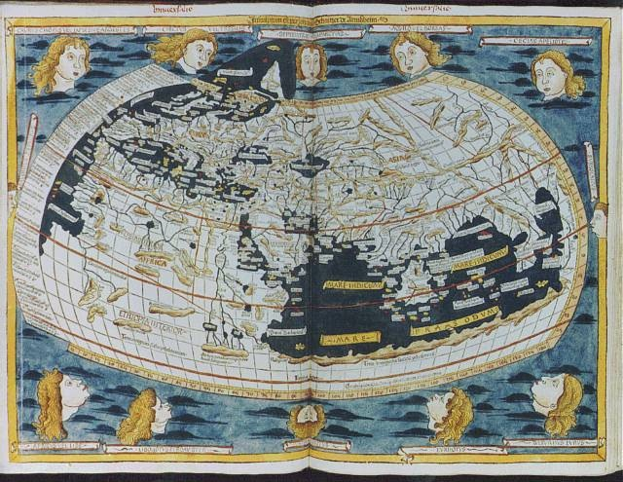
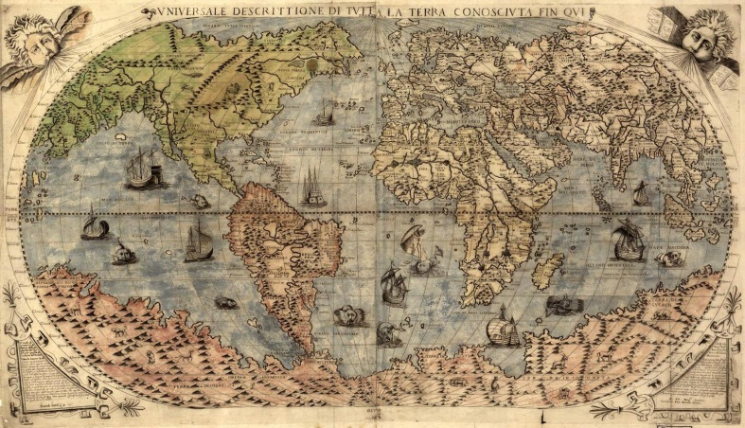

17. What was the overall goal of Portugal and Spain’s explorations? To find a sea route to Asia.
18. After finding a sea route around Africa, the Portuguese soon destroyed the Arab monopoly on the spice trade in the INDIAN Ocean.
19. Portuguese sailed east, around AFRICA . Spain sailed west across the ATLANTIC Ocean.
20. The voyages of Christopher Columbus (an Italian) were financed and sponsored by Queen Isabella of Spain (name the country).
21. The Treaty of Tordesillas negotiated by the pope, divided the unexplored world between Spain and Portugal.
22. America gets its name from whom? Amerigo Vespucci
23. Spanish conquerors were known as conquistadors.
24. Hernan Cortes of Spain, defeated the Aztec Empire of Mexico (Mexico or South America?).
25. Francisco Pizarro of Spain defeated the Incan Empire of South America (Mexico or South America?).
26. Which European group settled in the northeast and named it New Netherland? The Dutch
27. An important motivation for European exploration was personal acclaim, or GLORY .
28. After capturing New Netherland from the Dutch in 1664, the English renamed it New York.
29. Which WAS NOT a reason for the Spanish defeat of both the Aztecs and Incans?
1. Took advantage of a civil war or made alliances with the enemies of the empire.
2. Spanish superior military technology
3. Advanced European agricultural techniques
4. European Diseases ravaged native populations
30. Which European nation colonized much of Canada and Louisiana? France
31. An important motivation for European exploration was the spirit of adventure.
32. This statement, “the prosperity of a nation depended on a large supply of gold and silver”, describes what type of economic system? Mercantilism
33. A large agricultural estate is called a(n) plantation.
34. The forced voyage of enslaved Africans across the Atlantic Ocean to the Americas refers to the Middle Passage .
35. Yay or Nay. Did European exploration lead to widespread destruction of native American cultures?
36. Complete the equation. Mercantilism: Gold + silver = national prosperity
37. Yay or Nay. Did European exploration lead to European prosperity and a true “world economy”?
38. In the system of mercantilism, mother countries used colonies as a source of raw materials and also as markets for exports.
39. What is the name given to the exchange of plants, animals, people (and diseases) between the Old World (Europe, Africa, Asia) and the New World (the Americas)? The Columbian Exchange.
40. What did ships’ captains use during the Middle Passage to make stored water more palatable (more pleasant to drink)? Kola Nuts
41. European diseases depopulated much of the Caribbean. How did European controlled sugar plantations in the Caribbean solve the worker shortage problem? African slaves.
42. Did Orange Trees originate in the Old World or the New World? Old World
43. The Catholic Church prohibited slavery. What was the name of the system established by the Spanish crown to get around this prohibition? Encomienda System
44. Yay or Nay. The African slave industry began in 1518 when the first European slave ship brought African slaves to the Americas.
45. Did the Atlantic Slave Trade have a positive or negative effect on the average African family? ___________________________________
Complete the Triangle Trade route. European ships took manufactured goods to
(#46) Africa where they were traded for (#47) African Slaves. Enslaved Africans were sent to the (#48) Americas and sold. Raw materials from the (#49) Americas were then shipped to (#50) Europe and the process began again.
51. Did potatoes originate in the Old World or the New World? New World
52. An important motivation for European exploration was to amass (gather) more and more GOLD!
53. The Dutch, English, and French, expanded into Asia through the establishment of
Companies to pursue their nation’s economic interests in the East.
54. Eventually, which nation gained nearly complete control of India? Great Britain
What was the name of the Company that achieved this? British East India Company
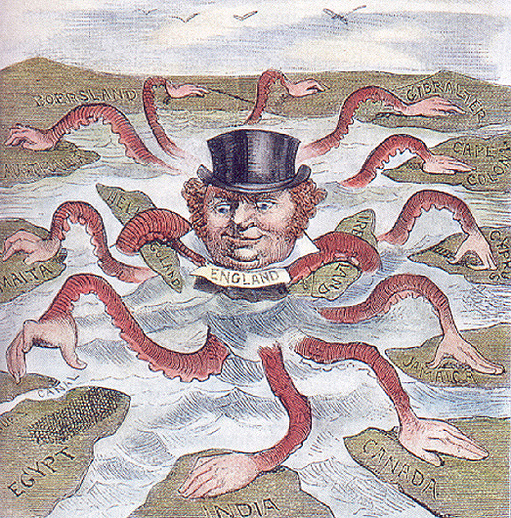
55. This cartoon represents the hegemony of what nation over the World? Great Britain
56. Complete the social class ladder for Colonial Latin America:
Top peninsulares
creole
mestizo mulatto
Native American African Slave
57. A peninsulare was a person born on the Iberian Peninsula but who served for a time in Colonial Latin America for political or economic gain.

Wake up every day and choose one thing to change that will make you a better person. One thing.

