Name: ___________________________ Block:_______ Date:____________________

TEST REVIEW – Chapter 13 - Use your notes from class lectures, your textbook, and guided readings to answer the following questions.

1. Who is the final prophet of Islam? __________________
2. Who was the first successor of Muhammad? _________________. What was his title? _________________.
3. What is the name of Islam’s holy book? _______________________
4. Which of the following apply to Abu Bakr, the first caliph? (Check off all that apply.)
_____ Wealthy merchant
_____ Muhammad’s father-in-law
_____ Muhammad’s companion on the Hijrah
_____ Muhammad’s chief advisor
5. Arabs lived on the ____________________ Peninsula in present day ______________ __________________.
6. Arab society, before Islam, was tribal, with each tribe ruled by a __________ . 7. Muhammad, the prophet of Islam, claimed revelations from God (Allah) through an angel. What was the angel’s name? ______________________
8. Before Islam, most Arabs were monotheistic. Is this statement true? ______
9. How did Muhammad view Jesus? __________________________________
10. True or False. Muhammad’s messages were written down immediately after each revelation from the angel Gabriel. _______________
11. What is the Islamic holy book called? _____________________
12. The principle teaching of the Quran is that there is only ________ ________, named ______________, and _______________________ is his prophet.
13. Was Muhammad and his followers accepted in his hometown (Mecca)?______ 14. The journey from Mecca to Medina in A.D. 622 is known as the __________ . 15. The beginning of the Islamic calendar is dated from what event? __________
16. True or False. Muhammad was a religious leader, but not a political or military leader. ______________
17. Islam is monotheistic. What does that mean? ________________________
_______________________________________________________________
18. What are the five pillars of Islam (English please):
1. _______________ 2. ____________________ 3. ________________
4. _______________ 5. ____________________
19. What is Arabic word for the pilgrimage to Mecca Muslims must take once in their lifetimes? ___________________________
20. Would an iconoclast be “ok” with a religious statue? __________________
21. What’s a caliph?
a. The successor to Herb Froman’s sausage empire.
b. The spiritual leader of all of Islam
c. The king of the Arabs
d. Religious and political successor to Muhammad
e. A governor of an Islamic province
22. Early Muslim warriors were promised a place in ________________ if they died in battle.
23. What happened to the first two caliphs after Abu Bakr? ________________
________________________________________________________
24. Who was the 3rd caliph, Muhammad’s son-in-law? ___________________
25. What are the two main branches of Islam? ___________________________
__________________________________________________________
26. Which branch of Islam accepts only the descendants of Ali as true caliphs?
_____________________________________________________
27. Which is the largest branch of Islam? _____________________
28. The split between the two branches of Islam is a result of: ______________
________________________________________________________
29. The covered market, or ________________, was a crucial trading center in every Muslim city or town.

30. Circle the year most closely associated with the first caliph, Abu Bakr:
313 632 800 33 B.C. 120 B.C.
31. Jews and Christians in Muslim territory paid a special tax and were often barred from certain jobs and schools. This status was called the
__________________________
32. Repeating geometric pattern art is called ______________________.
33. In Islam, is it acceptable to have a statue of Muhammad in a mosque?
____________________________________
34. Where do Muslims worship? __________________________
35. What are the tall towers attached to Muslim houses of worship called?
_________________________________
36. What is the crier who calls the faithful to prayer called? _________________
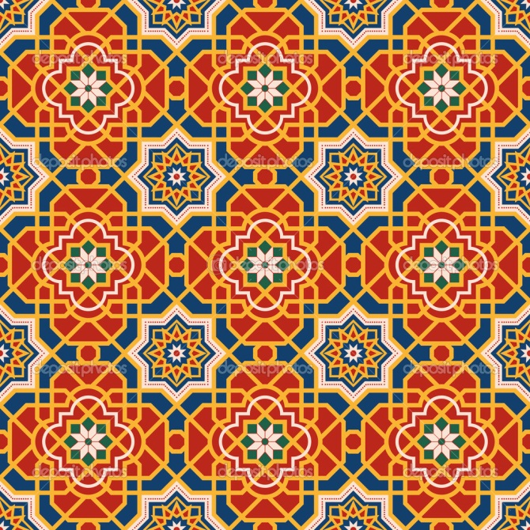
37. What type of art is represented in this picture? ____________________

38. What is represented in the picture below? ____________________________
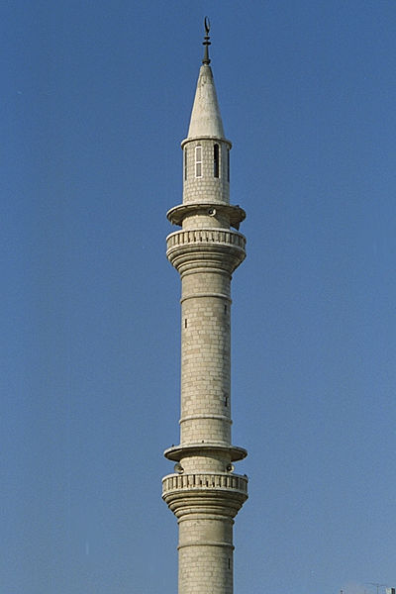

Answer Key:
1. Muhammad
2. Abu Bakr, caliph
3. Quran or Koran
4. All of them apply
5. Arabian, Saudi Arabia
6. sheikh
7. Gabriel
8. False
9. Muhammad viewed Jesus as a prophet.
10. False
11. Quran or Koran
12. one God, Allah, Muhammad
13. No
14. Hijrah
15. Hijrah
16. False. Muhammad was both a political and religious leader.
17. Monotheism is belief in one God.
18. Prayer, True Belief, Fasting, Pilgrimage (Hajj), Charity
19. Hajj
20. No
21. d. Religious and political successor to Muhammad
22. paradise
23. They were assassinated
24. Ali
25. Sunni and Shi’ite (Shia)
26. Shi’ite (Shia)
27. Sunni
28. The split between the branches is a result of a disagreement as to who should be the caliph.
29. bazaar
30. 632
31. dhimmitude
32. arabesque
33. No
34. mosque
35. minarets
36. muezzin
37. arabesque
38. minaret

