Name: ___________________________ Block:_______ Date:____________________

TEST REVIEW – Chapter 4 - Use your notes from class lectures, your textbook, and guided readings to answer the following questions.

1. The name of Charlemagne’s empire was the ____________________ Empire.
2. _________________ grew out of the breakup of the Carolingian Empire.
3. What was the name of the Norman conqueror who invaded England in 1066? _______________________ Was he successful? __________________ (pg 73)
4. What internal factor after Charlemagne’s death weakened kingdoms in Europe?
_______________________________
What external factor? ______________________________
5. Less than 30 years after Charlemagne’s death in 814, the Carolingian Empire
was divided among _____________________________.
6. What was the name given to the raiders and traders who swept across Europe
out of Scandinavia in the 9th and 10th centuries? _____________________
7. What was the name of the land given to Vikings in 911 by the West Frankish
King? ____________________________
8. The Vikings who settled in the land mentioned in #7 became known as
____________________________.
10. What happened to number 9? ______________________________________
11. What three modern countries did the Vikings come from? _______________
_______________________________________________________________
12. The region that the Vikings came from was called ______________________.
13. What was the name of the new political and social order that grew out of the
fall of the Carolingian Empire? ___________________________
14. A warrior who served a lord in return for a fief was known as a ___________. 15. What two technological advances led to the introduction of the mounted and
armored knight? ________________________________________________
16. The grant of land made from a lord to a vassal was known as a ___________.
17. What was wealth based on primarily in the Early Middle Ages? ____________
18. What was the chief virtue in feudal society? __________________________
19. The relationship between a lord and his vassal was not written down but was understood by all parties. This relationship was a set of mutual obligations known as the ___________________________. What does the word mutual above mean in this context? _______________________________________________
__________________________________________________________________
20. European feudal society was dominated by __________________.
21. The Catholic Church promoted the idea of __________________, a code of
ethics knights were supposed to uphold.
22. Did the status of women generally see improvement during the Middle Ages or did it get even worse? __________________________________________
23. In the Middle Ages, could European women legally hold property? _________
24. Changes in technology aided the growth of farming. What was the effect of this increased food production? _______________________________________
25. What was a carruca used for? ____________________________________
__________________________________________________________
26. The _________________ ________________ was one in which nobles held
large tracts of land worked by serfs and skilled artisans in a self-contained
community.
27. What is the name for a peasant legally bound to his lord’s land?
_____________________
28. In Medieval Europe, an agricultural estate that a lord ran and serfs worked
was called a ______________________.
29. What were the two primary reasons for the growth of cities in the Middle Ages? _________________________________________________________
30. The new small business class of merchants and artisans from the European cities was called the burghers, or _________________________.
31. In 1066, the ___________________________ invaded England. Remember them? They were in questions 7 & 8 above?
32. In 1215, the English King John was forced by his nobles to sign a document
that limited the powers of the king for the first time. It was called the
_______________________________.
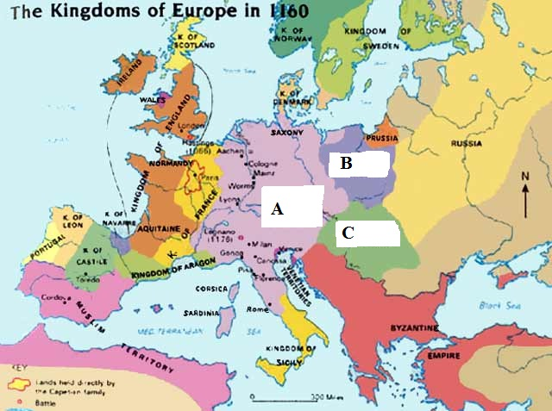
33. The name Russia is derived from the Rus, which was a name the native peoples of the region called the ___________________ who had plundered and dominated the area.

34. Identify the kingdoms / empires labeled on the map.
A. _____________
________________
B. _____________
________________
C. _____________
________________

35. Some eastern Slavic peoples were converted to __________________ by the missionary brothers, __________________ and __________________ .
36. What three modern day countries were the Vikings from? ________________
_______________________________________________________________________________

Wake up every day and choose one thing to change that will make you a better person. One thing.
Answer Key:
1. Carolingian 2. feudalism
3. William the Conqueror, yes
4. internal – civil war between his grandsons; external – invasions from Vikings
5. grandsons 6. Vikings
7. Norman 8. Normans
9. eaten
10. 7 8 9
11. Denmark, Sweden, Norway
12. Scandinavia
13. feudalism
14. vassal
15. stirrup and larger horses
16. fief
17. land
18. loyalty to one’s lord
19. feudal contract, both sides had obligations toward each other.
20. warriors
21. chivalry
22. improved
23. yes
24. population explosion
25. plowing fields
26. Manorial System
27. serf
28. manor
29. the revival of trade and the population explosion
30. bourgeoisie
31. Normans
32. Magna Carta
33. Swedish Vikings
34. a. Holy Roman Empire b. Kingdom of Poland c. Kingdom of Hungary
35. Orthodox Christianity, Cyril and Methodius
36. Denmark, Norway, and Sweden

