Name: ___________________________ Block:_______ Date:____________________

TEST REVIEW – Chapter 9 - Use your notes from class lectures, your textbook, and guided readings to answer the following questions.

1. Three factors made ITALY perfect as the birthplace of the Renaissance.
2. By the early 15th century, FIVE major territorial states dominated Italy.
3. One of the factors that made Italy perfect as the birthplace of the Renaissance was that it lacked a centralized governing MONARCHY .
4. Another factor that made Italy perfect as the birthplace of the Renaissance was that it was much more URBAN than the rest of Europe.
5. Prior to the Renaissance, Italy had a thriving TRADE network based in Italian cities.
6. Name the five major Italian territorial states in the early 15th century:
1. MILAN 2. VENICE 3. FLORENCE
4. THE PAPAL STATES 5. KINGDOM OF NAPLES
7. Which of the five major Italian states was controlled by the papacy? THE PAPAL STATES
8. The Visconti family is associated with what Italian city-state? MILAN
9. Which Italian city-state served as a commercial link between Asian and Western Europe? VENICE
10. The ruler of Venice was called the DOGE .
11. Which Italian city-state was associated with the Medici family? FLORENCE
12. Which Italian city-state was considered the cultural center of Renaissance Italy? FLORENCE
13. Savanarola, the Dominican priest, preached against the corruption of what ruling family? MEDICI
14. Which of the five territorial states of Italy was ruled by a hereditary monarch? KINGDOM OF NAPLES
15. Who wrote, The Prince? NICCOLO MACHIAVELLI
16. What was the eventual fate of Savanarola? HE WAS CONVICTED OF HERESY AND SENTENCED TO DEATH.
A 17. A key intellectual movement of the Renaissance was
a. humanism b. Marxism
c. philosophy d. scholasticism
18. The father of Italian Renaissance Humanism was FRANCESCO PETRARCH.
19. Another name for the local, spoken language is the VERNACULAR .
_____ 20. Humanism was based on the study of the
a. Bible
b. Greek and Roman classics
c. writings of Thomas Aquinas
d. Summa Theologica
21. Dante is most famous for writing what book? THE DIVINE COMEDY
22. Did Dante use the vernacular or Latin? VERNACULAR
23. Why did Northern Renaissance painters paint in smaller spaces than their Italian Renaissance peers? They lacked wall space (in contrast to the Italian artists who had gobs and gobs of churches in which to paint).
24. A painting done on wet plaster with water based paints is called a FRESCO .
25. Name the development (or invention) that brought about an information revolution: THE PRINTING PRESS
26. In almost ALL Renaissance art, there is an overarching, dominant theme. What is it? RELIGION
27. Which artist perfected the technique of oil painting? VAN EYCK
28. Who developed the moveable type printing press? Johannes GUTENBERG
29. Was Renaissance education’s goal to create a well-rounded individual, educated in a variety of subjects or to create a highly focused individual, educated in just one subject? THE GOAL OF RENAISSANCE EDUCATION WAS TO CREATE AN INDIVIDUAL WELL ROUNDED PHYSICALLY AND MENTALLY.
30. In the Italian Renaissance, did education become more religiously based or more secular? MORE SECULAR
31. In the question above, does secular mean worldly, non-religious or spiritual, religious?
SECULAR MEANS WORLDLY, NON-RELIGIOUS
32. The Book of the City of Ladies, was written as a defense of women by CHRISTINE DE PIZAN
33. The Big Three, Masters of the High Renaissance, were
1. MICHELANGELO
2. LEONARDO DA VINCI
3. RAPHAEL
34. In the Renaissance, marriages were arranged to strengthen business or FAMILY ties.
35. Small business owners, craftsmen, tradesmen of towns and cities were called BURGHERS . In France and Holland they were called BOURGEOISE .
36. What was the central theme of The Prince? The central theme is TO GAIN AND KEEP POLITICAL POWER.
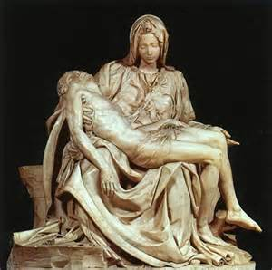
37. Name the sculpture and the artist (right):
THE PIETA by
MICHELANGELO
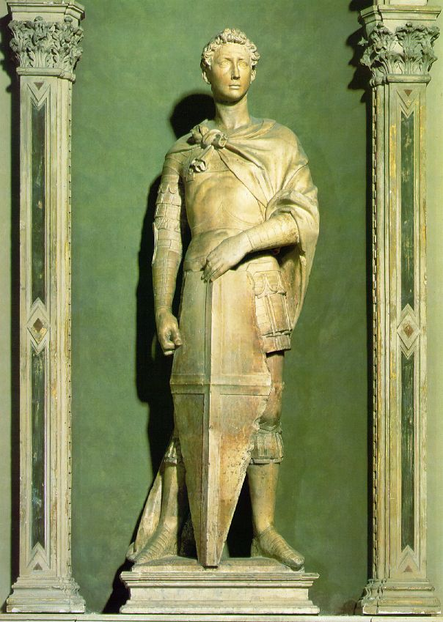

38. Name the sculpture and the artist (left):
ST. GEORGE by
DONATELLO

39. Another name for an Italian Renaissance father was the PATERFAMILIAS

40. This ruler, who overthrew the Medici family, prohibited or regulated the Florentines’ gambling, horseracing, books, painting, music, and even, wait for it,… swearing <shocked expressions!>: SAVANAROLA
41. In the Italian Renaissance, who was the center of the family? THE FATHER
42. What were the three major factors that made Italy perfect as the birthplace of the Renaissance?
1. ITALY LACKED A CENTRALIZED GOVERNING MONARCH.
2. ITALY WAS MUCH MORE URBAN THAN THE REST OF EUROPE
3. A THRIVING TRADE NETWORK WAS ALREADY IN PLACE IN ITALIAN CITIES
43. Flemish artists typically placed their subject among EVERYDAY OBJECTS.
44. Did Flemish artists belong to the Italian or Northern European group of Renaissance artists? NORTHERN EUROPEAN
45. Renaissance artists and sculptors studied HUMAN ANATOMY to capture more realism in their art.

Wake up every day and choose one thing to change that will make you a better person. One thing.

