Period 5 Review 1750 – 1900

1. Periodization question. Why does 1750 to 1900 get its own Period? (Your answer must address both the start date and end date to this period)

2. What are the two big I’s that define this period? Give a brief description of each (in your own words).

3. What are the four major political revolutions that occur during this period (in order)?

4. What political revolution inspired the others?

5. Which of the four major political revolutions was a successful slave revolt? Who was its leader? What was he inspired by?

6. Which of the four major political revolutions was essentially an internal conflict (civil war)?

7. Which political revolution gave rise to the circumstances that allowed for the rise of Napoleon Bonaparte?

8. Which political revolution is Simon Bolivar associated with? What was his overall goal? Did he reach this goal?

9. Revolutionary figures such as Thomas Jefferson, John Adams, and Simon Bolivar, were inspired by the _________________________________, an intellectual movement of the 1700s which centered on the idea of reason being the primary source of authority, and which espoused ideas of liberty, natural rights, limited constitutional government, private property rights, among other ideas.
10. Who attended the Berlin Conference?

What did it accomplish?

Who wasn’t invited?

When did it occur?

11. Which revolution is the Reign of Terror associated with?

In brief, what is it?

12. Which revolution began with a king and ended with an emperor?
13. Against which country was Toussaint L’Ouverture and the Haitian slaves rebelling?

14. The causes (in brief) of the Latin American (including Brazil) revolutions were
- Political and social inequality
  - Place the following social classes in order from top to bottom: Mestizos, Native Americans, Creoles, Peninsulares, Mulattoes

  - Who were the Peninsulares?

- Enlightenment ideas
- The Inspiration of the _________________________ Revolution
- Napoleon’s Actions were a CAUSE of which Latin American revolution?

15. Associate the following individuals with their Revolution:
- Simon Bolivar ____________________________________________
- Thomas Jefferson ____________________________________________
- Maximillien Robespierre ____________________________________________
- John Adams ____________________________________________
- George Washington ____________________________________________
- Jose San Martin ____________________________________________
- Father Miguel Hidalgo ____________________________________________

16. One commonality between the revolutions of this age is that they were ALL spurred on by ___________________________ ideas, or the idea of a shared feeling of common political identity by the people within a geographic region.
17. Associate the phrase with the correct revolution – Haitian, French, American, or Latin American:
“Resisted Britain’s attempts to impose taxes and trade controls on the colonies.” _________________________
“King imposed new taxes to pay nation’s debts. Food shortages due to bad harvests.” _____________________
“Slaves wanted freedom. Free people of color wanted citizenship.” ____________________________________
“Inspired by the American Revolution. Resented taxation and control of mother countries.” ________________ _______________________________________________________
18. Where did the Industrial Revolution begin?
Why did it occur there?

Give two of the reasons you just mentioned that also pertain to China during this time:

19. Why were the first factories built on rivers?

What invention allowed factories to move inland?

What was perhaps the greatest industrial use this invention was put toward?

20. Did the Polish priest Copernicus propose a universe model that was earth centered or sun centered? ___________________________ The scientific term for this is _________________________.
21. The ________________________ proposed that humans were basically good and that education and reason could improve humans even further.
22. The idea of monarch (king or queen) having a divine “_________________ ______ __________________” gave way to a form of government in which the government was given its rights and responsibilities by the consent of the governed (which is an Enlightenment idea).
23. The Enlightenment philosopher _______________ _______________ inspired American revolutionary thinkers such as Thomas Jefferson and Thomas Paine. He wrote about humans having unalienable rights such as the rights to life, liberty, and property.
24. _____________________________________ principles are reflected in the U.S Constitution, such as freedom, equality, and the idea of popular sovereignty, which means that the people have the right to constitute their own government and the right to dissolve that government when it no longer serves the people.
25. Was the French Revolution an internal struggle or an external struggle? _______________________
26. The world’s only successful slave revolt led to the establishment of the Republic of _____________________ .
27. Who was the leader of the Haitian slave revolt of 1791? ___________________________________
28. Who was the South American revolutionary inspired by George Washington? __________________________________
29. The Haitian revolution was the only revolution of the period 1750-1900 that was initiated and fought by
  - Creoles b. Mestizos c. Slaves
d. Foreign mercenaries e. Elite classes
30. The American and French Revolutions were alike in all the following ways EXCEPT
  - They both brought increased political power for women
  - They were prompted by issues of taxation
  - They both involved representation in their respective legislatures
  - They produced document that defined similar natural rights
  - They were based on Enlightenment thought

31. The Brazilian independence movement
  - Resulted in the abolition of slavery
  - Produced a republic for Brazil
  - Involved a prolonged struggle with Portugal
  - Followed a pattern similar to that of other Latin American independence movements
  - Was the result of the Napoleonic wars

32. __________________________ is the state of an industrialized nation dominating another nation, usually economically. Further, it is connected to and related to both the Industrial Revolution and Colonialism.

_____33. True or False. Imperialism is always accomplished through military force.

34. The success of Imperialism was due primarily to ____________________________________________.

_____35. Which of the following was NOT an economic motive of Imperialism?
A. Desire for wealth
B. Need for Raw Materials
C. Increasing strategic supply points for the military
D. Need for markets for industrial products

36. How did Europeans (and Americans) morally justify their Imperial empires?

37. The British gov’t took control of India from the British East India Company because
A. the publication of the Communist Manifesto
B. the invasion of Chinese forces
C. the Sepoy rebellion
D. the East India Company never lost control of India

38. The two African nations that escaped European Imperial control were _____________________________
_____________________________________________________.

39. Menelik II is associated with African resistance in ______________________________.

40. What territories did the United States gain from winning Spanish American War? _____________
_______________________________________________________________________________________.

41. Which American president is most associated with the building of the Panama Canal?
_______________________________________________________________________________________.

42. Name the canal connecting the Indian Ocean (through the Red Sea) and Europe? ______________________
What country did this canal cut through? ________________________________
43. What is “The White Man’s Burden”? ___________________________________________________________
_____________________________________________________________________________________ _______________________________________________________________________________________.

Given a map, could you identify the following:
- Birthplace of the Industrial Revolution
- Europe
- Japan
- Haiti
- France
- 13 American colonies
- The region of the world where Simon Bolivar fought for Independence from Spanish rule

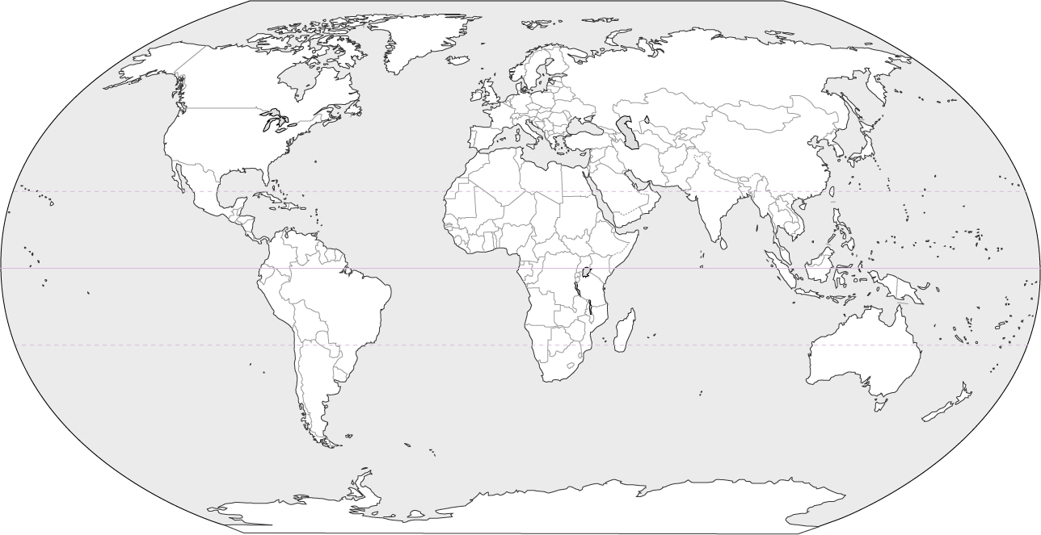

The Peace of Wild Things by Wendell Berry

When despair for the world grows in me
And I wake in the night at the least sound
In fear of what my life and my children’s lives may be,
I go and lie down where the wood drake
Rests in his beauty on the water, and the great heron feeds.
I come into the peace of wild things
Who do not tax their lives with forethought of grief.
I come into the presence of still water.
And I feel above me the day-blind stars
Waiting with their light. For a time
I rest in the grace of the world, and am free.

1. 1750 – start of political revolutions, industrial revolution, capitalism
1900 – Decline of Empire (Ottoman, China, Russia), Rise of Nationalism, WWI
2. Imperialism and Industrialization

23. John Locke
24. Enlightenment principles

