Name: ___________________________ Block:_______ Date:____________________

TEST REVIEW – The World Wars of the 20th century
Use your notes from class lectures, your textbook, and chapter summaries to answer the following questions.

1. World War I was fought in the first part of what century? _________________________________
2. World War I was fought primarily on what continent? _________________________________
3. Which of the following were major causes of World War I?
a. Nationalism b. Militarism
c. Imperialism d. a crisis in the Balkans
e. All of the Above were major causes of World War I
4. _________________________________ is the build-up of a nation’s armed forces in preparation for war.
5. The growth of _________________________________ in the last half of the nineteenth century also played a role in the coming of war. Countries competed for lands in other parts of the world, especially in Africa. This led to conflict, and it increased the rivalries among European states.
6. By 1914, the two major European alliances were the _________________________________and the _________________________________.
7. Where was Archduke Francis Ferdinand of Austria-Hungary assassinated? ____________________________
8. Two American inventions, the ____________________________ and ________________________________ brought about a new type of warfare – trench warfare.
9. World War I was a ___________________________, meaning that virtually all of society was mobilized behind the war effort.
10. When did World War I end and what treaty ended the war? _________________________________
__________________________________________________________________
11. Why did Russia withdraw its troops from the war? _________________________________ __________________________________________________________________
12. Who assassination sparked World War I? ______________________________________________________ 13. The Triple Alliance was between what three nations? ____________________________________________
__________________________________________________________________
14. The Triple Entente was between what three nations? ____________________________________________
__________________________________________________________________
15. Loyalty and devotion to a nation; especially: a sense of national consciousness exalting one nation above all others and placing primary emphasis on promotion of its culture and interests as opposed to those of other nations describes ________________________________one of the root causes of World War I.

16. Four things contributed to the start of World War I. What were they? ___________________________________________________________________________________________
17. Prior to World War I, Serbia was supported by what large country? ________________________________
18. What was Austria-Hungary’s response to the assassination of Archduke Francis Ferdinand? ___________________________________________________________________________________________
19. What country did Germany cross through to invade France (in both World Wars)? ________________________________________________________________
20. In WWI, who were the main Allied Powers? ____________________________________________________
________________________________________________________________
21. In WWI, who were the main Central Powers? __________________________________________________
________________________________________________________________
22. Most of World War I was fought through what type of warfare? ________________________________
23. At the start of WWI, what was the official U.S. position? ________________________________
24. By April 1917, unrestricted German naval warfare brought the ________________________________into the war.
25. In 1917, the ________________________________OR ________________________________revolution swept across Russia.
26. What event allowed Germany to launch a new offensive in France in 1918? __________________________
________________________________________________________________
27. Two things primarily brought about the end of WWI in 1918. What were they? _______________________ _____________________________________________________________________________
28. Another name for a truce, or cease-fire, is ________________________________.
29. Who was the U.S. president during World War I? ________________________________
30. Under the Treaty of Versailles, Germany had to pay crippling ________________________________to cover the cost of the war to the afflicted countries.
31. Under the Treaty of Versailles, Germany had to pay war reparations, lost territory, and had to drastically reduce the size of its ________________________________________________________________.
32. Under the Treaty of Versailles, Austria-Hungary was divided into these four countries: _________________
________________________________________________________________
33. After WWI, what happened to the Ottoman Empire? ________________________________ ________________________________________________________________.
34. This organization was proposed by President Wilson to bring an end to all wars through diplomacy:
________________________________
35. Adolf Hitler believed Germans were a superior race he called the ____________________________ race.
36. In the years prior to WWII, Adolf Hitler grossly violated which treaty?
________________________________________________________________
37. Did Europe use force to uphold the Treaty of Versailles? ________________________________
38. Giving in to demands in order to keep peace is called a policy of ________________________________.
39. The Rome-Berlin Axis was between German and what nation? ________________________________
40. Who was the fascist leader of Italy during WWII? ________________________________
41. Who was primary supporter of the policy of appeasement? ________________________________
________________________________
42. The invasion of what country in 1939 prompted Great Britain and France to declare war on Germany?
________________________________
43. What was the initial US response to Japanese aggression in China? ________________________________
________________________________
44. Many historians date the start of WWII with the Japanese invasion of ________________________________ in 1931.
45. Another name for Hitler’s mechanized, lightning warfare is… ________________________________
46. Did the Germans win the Battle of Stalingrad? _____________In what country was it fought? ________________________________
47. The United States entered the war after ____________________________________________________ _______________________________.
48. The name given to the invasion of France by allied forces on June 6, 1944: __________________________
49. General Douglas MacArthur took the ________________________________from the Japanese in the fall of 1942, fulfilling his promise to return to the archipelago.
50. Was the Battle of Britain a naval battle, land battle, or air battle? ________________________________
51. In the Battle of Britain, what new technology gave Great Britain an edge? ___________________________
52. The United States dropped atomic bombs on ________________________and _______________________ ending the conflict with Japan.
53. The Allies opened up two fronts in the war in Europe. The first front was in the south, through the invasion of Italy. The second front crossed the English Channel to invade ________________________________.
54. The Nazis rounded up ___________________and sent them to concentration camps; the Nazis killed approximately 6 million ___________________ during the Holocaust.
55. Great Britain and the United States, democracies with capitalistic economies, found themselves allied with the ________________________________ a communist, totalitarian country.
56. The United States entered the war on the Allied side after the Japanese attacked ________________________________.
57. Germany invaded ________________________________ prompting Great Britain and France to declare war on Germany.
58. Adolf Hitler annexed which country? ________________________________
59. After World War II, political tensions, suspicions, and a conflict of ideology led the U.S. and the U.S.S.R. into the ________________________________
60. The war against Germany and Italy was fought primarily on what continent? _________________________
61. The war against Japan was fought primarily in what ocean? ________________________________
62. Who were the two U.S. presidents during World War II? ________________________________
________________________________________________________________

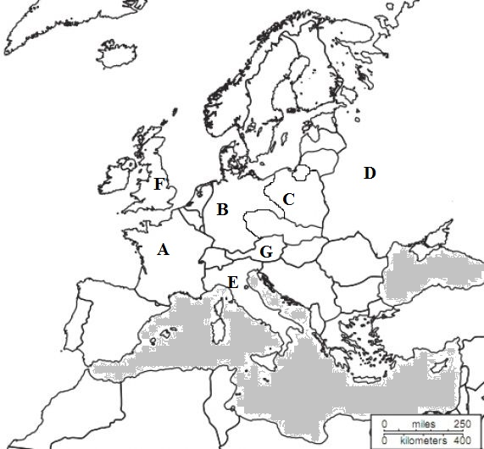

Identify the countries, A – G, in this World War II map.

As you think, so shall you become.

