Name: ___________________________ Block:_______ Date:____________________

TEST REVIEW – The World Wars of the 20th century
Use your notes from class lectures, your textbook, and chapter summaries to answer the following questions.

1. World War I was fought in the first part of what century? 20th
2. World War I was fought primarily on what continent? Europe
3. Which of the following were major causes of World War I?
a. Nationalism b. Militarism
c. Imperialism d. a crisis in the Balkans
e. All of the Above were major causes of World War I
4. Militarism is the build-up of a nation’s armed forces in preparation for war.
5. The growth of IMPERIALISM in the last half of the nineteenth century also played
a role in the coming of war. Countries competed for lands in other parts of the world, especially in Africa. This led to conflict, and it increased the rivalries among European states.
6. By 1914, the two major European alliances were the TRIPLE ALLIANCE and the TRIPLE ENTENTE .
7. Where was Archduke Francis Ferdinand of Austria-Hungary assassinated? SERBIA
8. Two American inventions, the MACHINE GUN and BARBED WIRE brought about a new type of warfare – trench warfare.
9. World War I was a TOTAL WAR , meaning that virtually all of society was mobilized behind the war effort.
10. When did World War I end and what treaty ended the war? 11 Nov 1918, TREATY OF VERSAILLES
11. Why did Russia withdraw its troops from the war? THE BOLSHEVIK (COMMUNIST) REVOLUTION AGAINST THE CZAR.
12. Who assassination sparked World War I? ARCHDUKE FRANCIS FERDINAND OF AUSTRIA-HUNGARY
13. The Triple Alliance was between what three nations? GERMANY, AUSTRIA-HUNGARY, ITALY
14. The Triple Entente was between what three nations? GREAT BRITAIN, FRANCE, RUSSIA
15. Loyalty and devotion to a nation; especially: a sense of national consciousness exalting one nation above all others and placing primary emphasis on promotion of its culture and interests as opposed to those of other nations describes NATIONALISM one of the root causes of World War I.
16. Four things contributed to the start of World War I. What were they?
Militarism; Alliances; Imperialism; Nationalism
17. Prior to World War I, Serbia was supported by what large country? RUSSIA
18. What was Austria-Hungary’s response to the assassination of Archduke Francis Ferdinand? AUSTRIA-HUNGARY DECLARED WAR ON SERBIA.
19. What country did Germany cross through to invade France (in both World Wars)? BELGIUM
20. In WWI, who were the main Allied Powers? GREAT BRITAIN, FRANCE, AND THE UNITED STATES
21. In WWI, who were the main Central Powers? GERMANY, AUSTRIA-HUNGARY, OTTOMAN EMPIRE
22. Most of World War I was fought through what type of warfare? TRENCH WARFARE
23. At the start of WWI, what was the official U.S. position? NEUTRALITY
24. By April 1917, unrestricted German naval warfare brought the UNITED STATES into the war.
25. In 1917, the BOLSHEVIK OR COMMUNIST revolution swept across Russia.
26. What event allowed Germany to launch a new offensive in France in 1918? RUSSIAN WITHDRAWAL DUE TO THE BOLSHEVIK REVOLUTION.
27. Two things primarily brought about the end of WWI in 1918. What were they? THE BRITISH BATTLE TANK AND THE ARRIVAL OF U.S. TROOPS.
28. Another name for a truce, or cease-fire, is ARMISTICE.
29. Who was the U.S. president during World War I? WOODROW WILSON
30. Under the Treaty of Versailles, Germany had to pay crippling REPARATIONS to cover the cost of the war to the afflicted countries.
31. Under the Treaty of Versailles, Germany had to pay war reparations, lost territory, and had to drastically reduce the size of its ARMED FORCES.
32. Under the Treaty of Versailles, Austria-Hungary was divided into these four countries: AUSTRIA, HUNGARY, CZECHOSLOVAKIA, and YUGOSLAVIA.
33. After WWI, what happened to the Ottoman Empire? BROKEN UP AND CEASED TO EXIST.
34. This organization was proposed by President Wilson to bring an end to all wars through diplomacy:
LEAGUE OF NATIONS
35. Adolf Hitler believed Germans were a superior race he called the ARYAN race.
36. In the years prior to WWII, Adolf Hitler grossly violated which treaty? TREATY OF VERSAILLES
37. Did Europe use force to uphold the Treaty of Versailles? NO
38. Giving in to demands in order to keep peace is called a policy of APPEASEMENT.
39. The Rome-Berlin Axis was between German and what nation? ITALY
40. Who was the fascist leader of Italy during WWII? BENITO MUSSOLINI
41. Who was primary supporter of the policy of appeasement? THE BRITISH PRIME MINISTER CHAMBERLAIN
42. The invasion of what country in 1939 prompted Great Britain and France to declare war on Germany? POLAND
43. What was the initial US response to Japanese aggression in China? THE U.S. THREATENED TO IMPOSE SANCTIONS ON JAPAN.
44. Many historians date the start of WWII with the Japanese invasion of MANCHURIA (NORTHERN CHINA) in 1931.
45. Another name for Hitler’s mechanized, lightning warfare is… BLITZKRIEG
46. Did the Germans win the Battle of Stalingrad? NO In what country was it fought? SOVIET UNION
47. The United States entered the war after THE JAPANESE ATTACK ON PEARL HARBOR, HAWAII.
48. The name given to the invasion of France by allied forces on June 6, 1944: D-DAY
49. General Douglas MacArthur took the PHILIPPINES from the Japanese in the fall of 1942, fulfilling his promise to return to the archipelago.
50. Was the Battle of Britain a naval battle, land battle, or air battle? AIR
51. In the Battle of Britain, what new technology gave Great Britain an edge? RADAR
52. The United States dropped atomic bombs on HIROSHIMA and NAGASAKI ending the conflict with Japan.
53. The Allies opened up two fronts in the war in Europe. The first front was in the south, through the invasion of Italy. The second front crossed the English Channel to invade FRANCE.
54. The Nazis rounded up JEWS and sent them to concentration camps; the Nazis killed approximately
6 million JEWS during the Holocaust.
55. Great Britain and the United States, democracies with capitalistic economies, found themselves allied with the SOVIET UNION (U.S.S.R.) a communist, totalitarian country.
56. The United States entered the war on the Allied side after the Japanese attacked PEARL HARBOR.
57. Germany invaded POLAND prompting Great Britain and France to declare war on Germany.
58. Adolf Hitler annexed which country? AUSTRIA
59. After World War II, political tensions, suspicions, and a conflict of ideology led the U.S. and the U.S.S.R. into the COLD WAR.
60. The war against Germany and Italy was fought primarily on what continent? EUROPE
61. The war against Japan was fought primarily in what ocean? PACIFIC OCEAN
62. Who were the two U.S. presidents during World War II? FRANKLIN D. ROOSEVELT AND HARRY TRUMAN

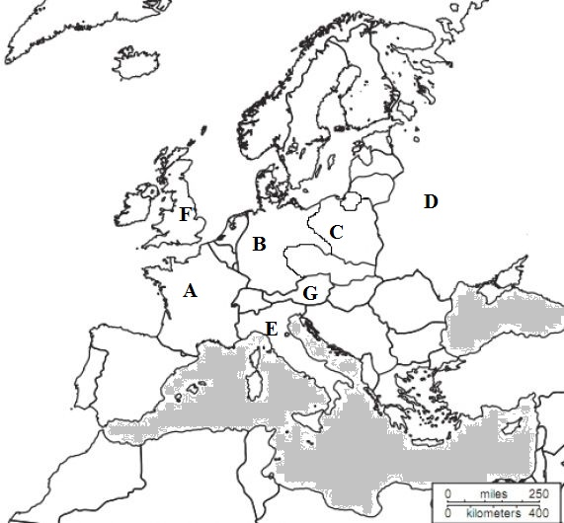

Identify the countries, A – G, in this World War II map.
A. FRANCE
B. GERMANY
C. POLAND
D. SOVIET UNION
E. ITALY
F. GREAT BRITAIN (ENGLAND)
G. AUSTRIA

As you think, so shall you become.

